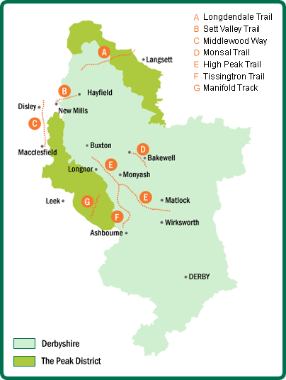
Kedleston Hall
Calke Abbey
Sudbury Hall
Midland Railway
Eyam Hall
Hardwick Hall
Bolsover Castle
Renishaw Hall
Peak Rail
Chatsworth House
Haddon Hall
Lyme Park
Castleton
Caves
Pooles Cavern
Peveril Castle
Tutbury Castle
Wingfield Manor
Tissington,
Ilam and Bradbourne Halls
Masson, Cromford and Belper Mills
Crich Tramway Museum
Carsington
Water
Alton Towers
Staffordshire Potteries
Nottingham Castle
The Lace Market
Sherwood Forest Visitor Centre
Galleries of Justice
Tales of Robin Hood
Gullivers Kingdom
Heights of Abraham
Rollorworld
Cinemas
Leisure Centres
Museums
Wirksworth Area
Wirksworth Stone Centre
Matlock Mining Museum
Crich Stand
Wirksworth Heritage Centre
Belper Industrial Museum
Ladybower
Derwent
Howden
Revervoirs

